POLICIES AND PROCEDURES

OSL.SOP.XVII.009
#32 Ultra-Cold Chain Decommission
WRE/SHO
OSL Standard Operating Procedure
Target Audience: Technical Logistic officers

DISCLAIMER

Standard Operating Procedures (SOPs) provide a step-by-step guide for staff directly involved in the processing of administrative actions to support and facilitate the implementation of WHO policies and procedures. The SOPs are for guidance only; they are neither authoritative nor binding. The SOPs reflect the policies and procedures of WHO at the time of writing; however, policies and procedures change from time-to-time. In the case of a conflict between the SOPs and the WHO e-Manual provisions, the WHO e-Manual provisions take precedence.

DOCUMENT SPECIFICATIONS

Version Version | Date of revision | Author (s) / Dept / Unit | Approver | Indicate which section (s) changed compared to previous version
0.1 | Oct 2018 | Jordi Sacristan / SHO/OSL | MOLINARO, Paul; COSTA, Alejandro;  AIT-IKHLEF, Kamal; | TO CLEARED

INTRODUCTION

  - Purpose
The purpose of this Standard Operating Procedure (SOP) is to describe the detailed process on Ultra Cold Chain Devises decommissioning after EVD vaccination activities ending, and how to dismount, re-pack and store the existing Ultra Cold Chain Infrastructure, aiming to minimize the risk of damage and preserve them for future interventions.

  - Scope
The information described in this SOP is for study staff involved in the activity of defining both Vaccination Rings following confirmation of an index case of Ebola Virus Disease (EVD), and front-line health workers at risk.

  - Principles
Ultra-Cold Chain infrastructure MUST be dismounted and packaged for proper storage and send it back to headquarters OR properly donated and transferred to the identified new custody owner.

Ultra-Cold Chain devises are sensitive material, and they must be kept and stored in clean and safe premises, under supervision of well-trained staff under supervision of UCC specialist technician.

Responsible personnel should ensure that the decommissioning and packaging process is correctly organized, and goods are stored in appropriate conditions.

MATERIALS

2.1. Passive Vaccine Carrier Devise (PVCD : Arktec©).

2.2. One Ultra Low-Temperature Freezer (ULTF; horizontal – 85 °C), for freezing PCM Packs.

2.3. One Ultra Low-Temperature Freezer (ULTF; vertical/horizontal -90 to 600 litres-, - 80 °C), for conservation of Ebola Vaccines.

2.4. Tow stabilizers (3000Va)

2.5. Electrical plug adaptors (depending on ULTF and stabilizer plugging formats).

2.6. Tools set (cutting pliers, screw drivers, knife, etc.)

PROCEDURES
  - Pre-assumptions:
        - Certificate of origin, importation documents, Air Way Bills, and user manuals.
    - Prepare donation letter together with WHO When receiving and installing the UCC devices, during the setup process, a pre-agreement is done regarding decommissioning process: either transferring and donating them to a partner, either to re-shipping back them to Headquarters.
    - In both cases, an adequate, clean, safe and protected space has been identified in advance together with partners (authorities, UNICEF, etc.), for recovering and repackaging all Ultra-Cold Chain devices (using the original packages, if possible).
    - Staff involved on the decommissioning and re-packaging UCC devices must be properly trained on their technical specifications, and in general knowledge in CC and UCC systems.
    - Any detected damage and/or need of maintenance/reparation must be reported immediately to the supervisor prior packaging, to ensure its application.
    - Shipping crates, packaging boxes, spare parts and none used items have been kept in good conditions, for the reconditioning process.

  - Decommission and Re-packing of the Ultra Cold Chain Devises:

    - When UCC Devices are returned, first check their general status, and ensure they are working properly. Report any damage or missing part — if any-, and/or check the original inventory list. Inform the OSL Supply/Technical units accordingly.
    - Clean and assemble all parts (including spare parts and consumables — if any-) and update the packing list accordingly before packaging and storage.
    - Empty and clean the PCM accumulators, recovering the PCM liquid inside the original container and seal them. Let the empty PCM accumulators dry for 24h before packing them back to the PVCD boxes.
    - Re-pack all UCC Device, in the original shipping crates and packing boxes (if kept), and label them properly, attaching the packing list updated.
    - Depending on of decommissioning pre-agreements, once all UCC materials are received, checked and packaged then proceed with either donation to the counterpart or shipping back to HQ Emergency Stock:

      - Process of Donation to the counterpart:

        - Prepare all required documents: Packing list, CO, following all administrative requirements indicated by Office,
        - Organize the donation event, with signature and official handover.
        - Inform all parts involved (including funding sources if required).

      - Process of Shipping back materials to HQ Emergency Stocks:

        - Prepare all required documents: Packing list, certificate of origin, importation documents, Air Way Bills, and user manuals.
        - Identify funds (PTAEO) for covering shipping cost from country to WHO HQ Warehouse.
        - With the support of the WHO CO, and in direct coordination with OSL supply/Technical Teams organize the transport back to HQ warehouse.
        - When arrived at the destination, ensure a goods' delivery check status and produce a final reception report, informing all parts involved.
        - Proceed with proper storage in the designated warehouse, ensuring adequate conditions. Keep all items grouped and clearly identified, for inspection purposes if needed.
        - Supervise them regularly and perform maintenance when required. Thus, goods will be ready for the next deployment.

REFERENCE MATERIALS

  - Related SOPs

- SOP#28_WHE-SHO-OSL- EVD vaccine Reception in the Country.
- SOP#31_WHE-SHO-OSL- Setup of Ultra-Cold Chain for EVD vaccination.
- SOP#_WHE-SHO-OSL- Packing EVD Vaccine for transportation to the Field.

- PROCESS FLOW
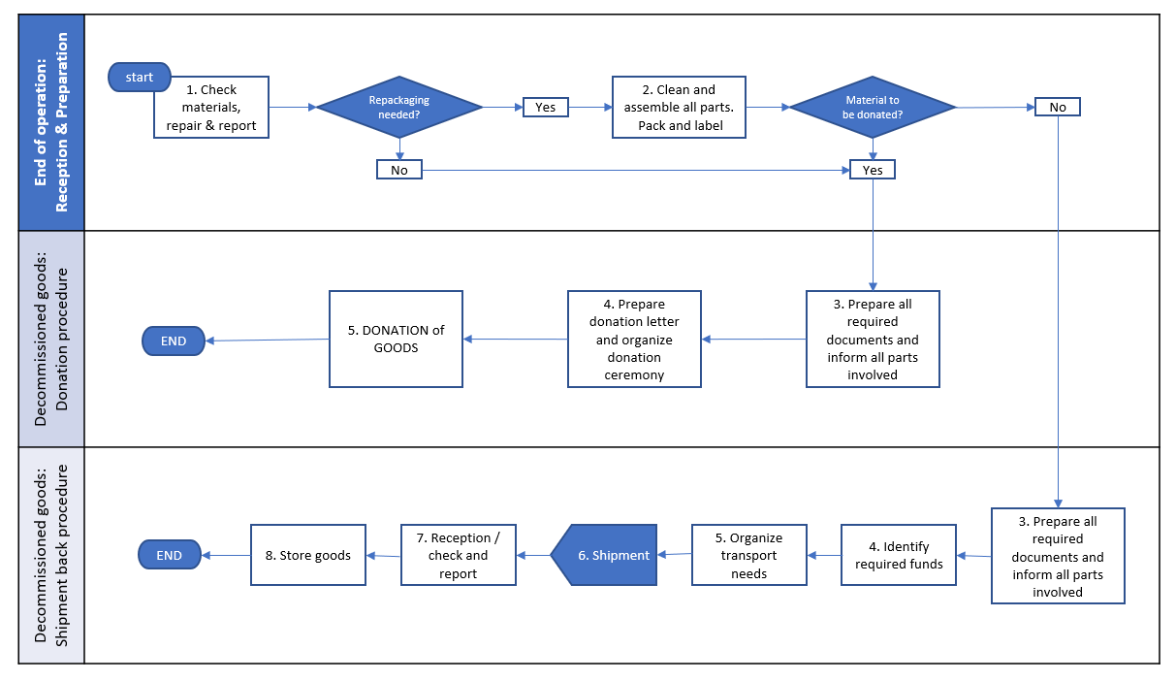

- GLOSSARY

ACC: | Active Cold Chain. Infrastructure depending on the power supply, with capacity unlimited cold production meanwhile there is an active power source.
CC: | Cold Chain System. Includes both active and passive devices (temperature ranges from -25 °C to 8 °C)
EVD: | Ebola Virus Diseases.
HQ | Headquarters. It refers to World Health Organization in Geneva.
LTF: | Low-Temperature Freezer. Active negative cold chain device. Provides temperatures from 0 °C to -25 °C.
OSL: | Operations Support and Logistics unit, in the Emergency Operations Department in WHO
PCC: | Passive Cold Chain. Infrastructure not depending on the power supply, but on passive devices with high capacity of heat absorption. Its capacity is time limited.
PCM: | Phase Changing Material. Refers to the liquid used in the accumulators of the PVCD or ARKTEC© devices.
PTAEO: | Budget Line defined inside the organization (WHO).
PVCD: | Passive Vaccine Carrier Device. Refers to the ARKTEC© devices.
TOR: | Terms of Reference. Detailed list of objectives and tasks for an identified working position.
UCC: | Ultra-Cold Chain. Include both active and passive devices (temperature ranges from -50 °C to -85 °C)
ULTF: | Ultra-Low Temperature Freezer. Active ultra-cold chain device. Provides temperatures from -50 °C to -85 °C.
UPS: | Uninterruptible power supply. Electrical device.
VC: | Vaccine carrier. Passive cold chain device. Provides temperatures from 2 °C to 8 °C, using ice packs.
WHO: | World Health Organization
WHO CO: | Country Office of WHO.

